**SAGNIK BASU 113EC0199**

**LAB 1**

**Logic gates using perceptron**

1) Two input or gates

% Run_or_Perceptron.m

P = [0 0 1 1; 0 1 0 1]; % or Function

T = [0 1 1 1];

plotpv(P,T,[-1, 2, -1, 2]); % plot data

% initial weight vector and bias

W = [1 1]; b = -1;

plotpc(W,b); % plot line

epoc = 1; % number of epoc for j=1:epoc

for i=1:size(P,2)

p = P(:,i);

t = T(i);

net=perceptron;

[W b] = train(p',t,W,b);

plotpc(W,b);

end end

% test data test = [0 0]' test = [0 0];

output = hardlim(W*test'+b)

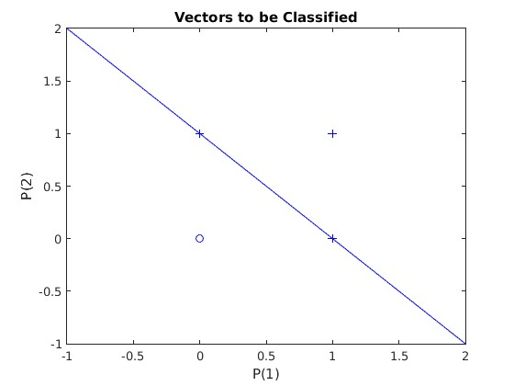

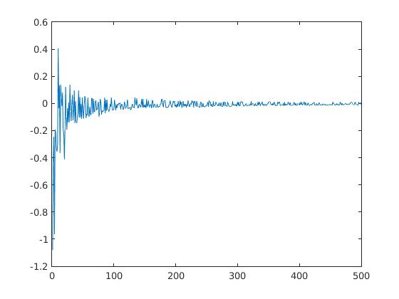

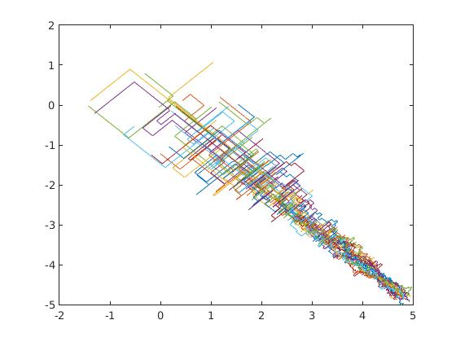

two input and gates

% Run_AND_Perceptron.m

P = [0 0 1 1; 0 1 0 1]; % AND Function

T = [0 0 0 1];

plotpv(P,T,[-1, 2, -1, 2]); % plot data

% initial weight vector and bias

W = [1 1]; b = -1;

plotpc(W,b); % plot line

epoc = 1; % number of epoc for j=1:epoc

for i=1:size(P,2)

p = P(:,i);

t = T(i);

net=perceptron;

[W b] = train(p',t,W,b);

plotpc(W,b);

end end

% test data test = [0 0]' test = [0 0];

output = hardlim(W*test'+b)

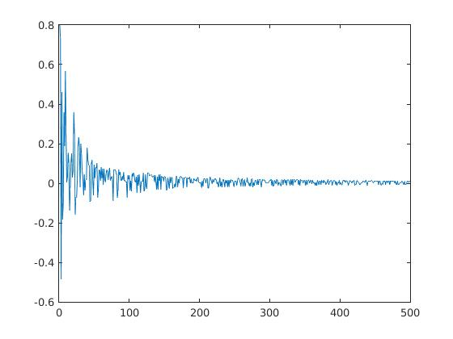



3)three 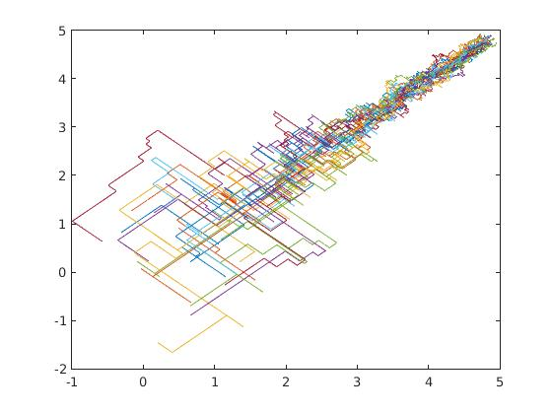



input or gates

4)three input and gates

clc;

clear all;

close all;

input=[1 -1 -1 -1 1 1 1 -1; 1 -1 1 -1 1 -1 -1 1;1 -1 1 1 -1 -1 1 -1];

%b=1;

output=[1 0 0 0 0 0 0 0];

weight=zeros(500,2,20);

bias = zeros(500,1,20);

err = zeros(500,1,20);

x=input;

t=output;

%[row col]= size(x);

%out = zeros(1,4);

for k=1:20

weight=rand([1,3])*2-1;

bias=rand([1,1])*2-1;

weight1(1,:,1)=weight;

bias1(1,:,1)=bias;

for j=1:500

r = randi(4);

x1(:,j)=x(:,r);

y(1,j)=(weight*x(:,r)+bias);

out(1,j) = (1/(1+exp(-y(1,j))));

e=t(r)-out(j);

bias=bias+e;

weight=weight+e.*transpose(x(:,r));

weight1(j,:,k)= weight;

bias1(j,1,k) = bias;

err(j,1,k) = e;

end

plot(weight1(:,1,k),bias1(:,1,k)); hold on;

end

for j= 1:500

ave = err(j,1,1);

for k =1:20

ave = ave + (err(j,1,k)/20);

end

mse(j,1)=ave;

end

[ x1' out']

figure;

plotpv(x,t);

plotpc(weight,bias);

figure;

plot(mse)

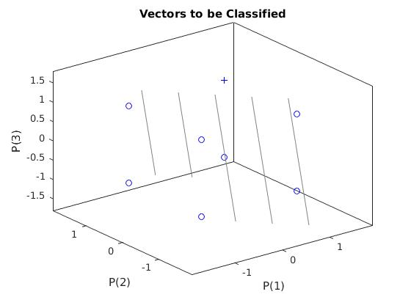

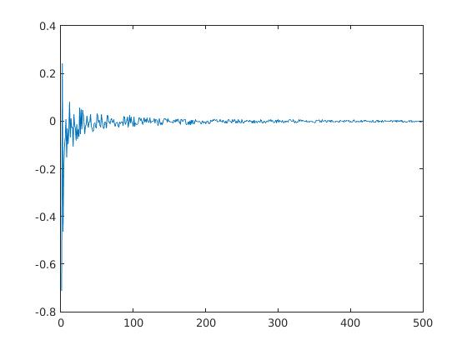

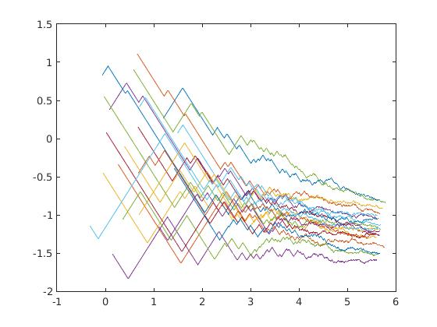

4)three input or gates

clc;

clear all;

close all;

input=[1 -1 -1 -1 1 1 1 -1; 1 -1 1 -1 1 -1 -1 1;1 -1 1 1 -1 -1 1 -1];

%b=1;

output=[1 0 1 1 1 1 1 1];

weight=zeros(500,2,20);

bias = zeros(500,1,20);

err = zeros(500,1,20);

x=input;

t=output;

%[row col]= size(x);

%out = zeros(1,4);

for k=1:20

weight=rand([1,3])*2-1;

bias=rand([1,1])*2-1;

weight1(1,:,1)=weight;

bias1(1,:,1)=bias;

for j=1:500

r = randi(4);

x1(:,j)=x(:,r);

y(1,j)=(weight*x(:,r)+bias);

out(1,j) = (1/(1+exp(-y(1,j))));

e=t(r)-out(j);

bias=bias+e;

weight=weight+e.*transpose(x(:,r));

weight1(j,:,k)= weight;

bias1(j,1,k) = bias;

err(j,1,k) = e;

end

plot(weight1(:,1,k),bias1(:,1,k)); hold on;

end

for j= 1:500

ave = err(j,1,1);

for k =1:20

ave = ave + (err(j,1,k)/20);

end

mse(j,1)=ave;

end

[ x1' out']

figure;

plotpv(x,t);

plotpc(weight,bias);

figure;

plot(mse)

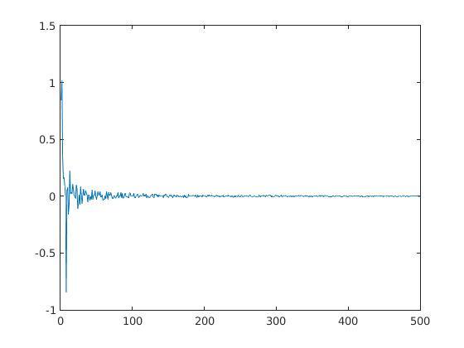

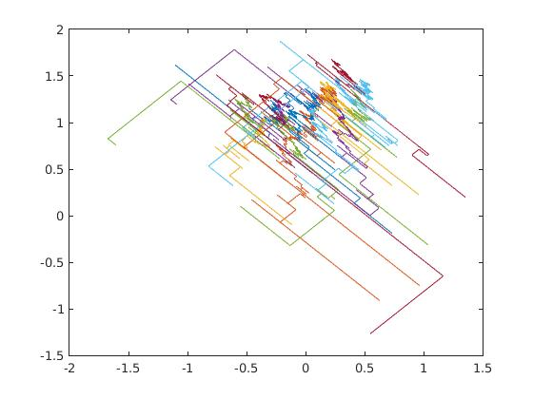

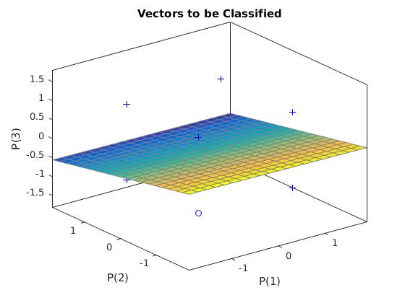

2 input nand gate

clc;

clear all;

close all;

%input=[1 1 1 1 1 1 1 1 -1 -1 -1 -1 -1 -1 -1 -1 ; 1 1 1 1 -1 -1 -1 -1 1 1 1 1 -1 -1 -1 -1; 1 1 -1 -1 1 1 -1 -1 1 1 -1 -1 1 1 -1 -1;1 -1 1 -1 1 -1 1 -1 1 -1 1 -1 1 -1 1 -1 ];

%b=1;

input=[1 1 -1 -1; 1 -1 -1 1];

output=[0 1 1 1];

weight=zeros(500,2,20);

bias = zeros(500,1,20);

err = zeros(500,1,20);

x=input;

t=output;

%[row col]= size(x);

%out = zeros(1,4);

for k=1:20

weight=rand([1,2])*2-1;

bias=rand([1,1])*2-1;

weight1(1,:,1)=weight;

bias1(1,:,1)=bias;

for j=1:500

r = randi(4);

x1(:,j)=x(:,r);

y(1,j)=(weight*x(:,r)+bias);

out(1,j) = (1/(1+exp(-y(1,j))));

e=t(r)-out(j);

bias=bias+e;

weight=weight+e.*transpose(x(:,r));

weight1(j,:,k)= weight;

bias1(j,1,k) = bias;

err(j,1,k) = e;

end

plot(weight1(:,1,k),bias1(:,1,k)); hold on;

end

for j= 1:500

ave = err(j,1,1);

for k =1:20

ave = ave + (err(j,1,k)/20);

end

mse(j,1)=ave;

end

[ x1' out']

figure;

plotpv(x,t);

plotpc(weight,bias);

figure;

plot(mse)

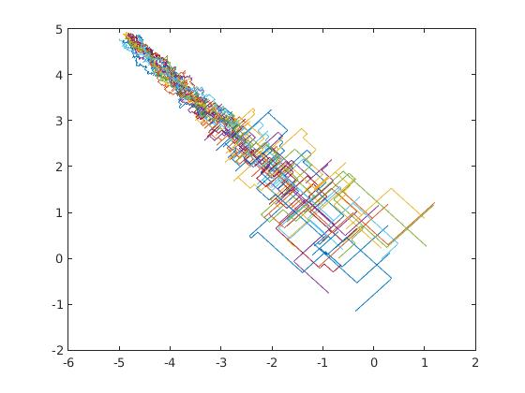

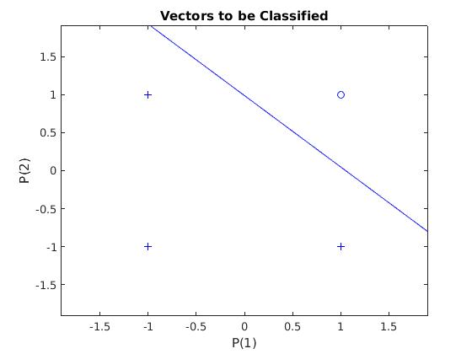

'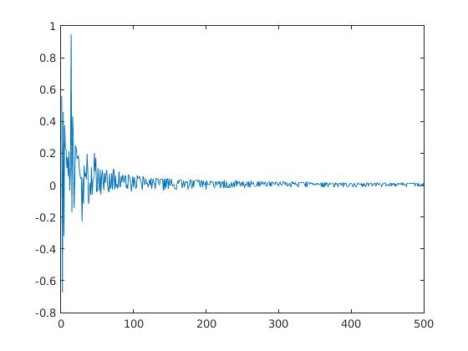

2 input nor gate

clc;

clear all;

close all;

%input=[1 1 1 1 1 1 1 1 -1 -1 -1 -1 -1 -1 -1 -1 ; 1 1 1 1 -1 -1 -1 -1 1 1 1 1 -1 -1 -1 -1; 1 1 -1 -1 1 1 -1 -1 1 1 -1 -1 1 1 -1 -1;1 -1 1 -1 1 -1 1 -1 1 -1 1 -1 1 -1 1 -1 ];

%b=1;

input=[1 1 -1 -1; 1 -1 -1 1];

output=[0 0 1 0];

weight=zeros(500,2,20);

bias = zeros(500,1,20);

err = zeros(500,1,20);

x=input;

t=output;

%[row col]= size(x);

%out = zeros(1,4);

for k=1:20

weight=rand([1,2])*2-1;

bias=rand([1,1])*2-1;

weight1(1,:,1)=weight;

bias1(1,:,1)=bias;

for j=1:500

r = randi(4);

x1(:,j)=x(:,r);

y(1,j)=(weight*x(:,r)+bias);

out(1,j) = (1/(1+exp(-y(1,j))));

e=t(r)-out(j);

bias=bias+e;

weight=weight+e.*transpose(x(:,r));

weight1(j,:,k)= weight;

bias1(j,1,k) = bias;

err(j,1,k) = e;

end

plot(weight1(:,1,k),bias1(:,1,k)); hold on;

end

for j= 1:500

ave = err(j,1,1);

for k =1:20

ave = ave + (err(j,1,k)/20);

end

mse(j,1)=ave;

end

[ x1' out']

figure;

plotpv(x,t);

plotpc(weight,bias);

figure;

plot(mse)

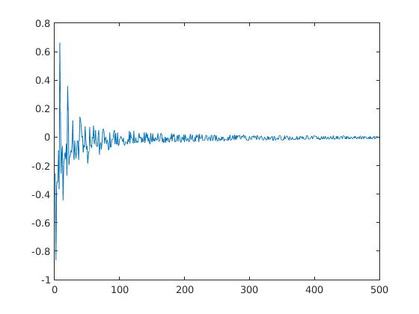

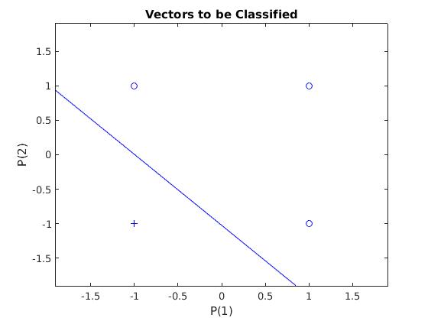

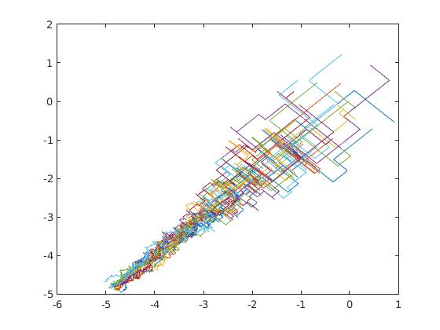

3 input nand gate

clc;

clear all;

close all;

%input=[1 1 1 1 1 1 1 1 -1 -1 -1 -1 -1 -1 -1 -1 ; 1 1 1 1 -1 -1 -1 -1 1 1 1 1 -1 -1 -1 -1; 1 1 -1 -1 1 1 -1 -1 1 1 -1 -1 1 1 -1 -1;1 -1 1 -1 1 -1 1 -1 1 -1 1 -1 1 -1 1 -1 ];

%b=1;

input=[1 1 1 1 -1 -1 -1 -1; 1 1 -1 -1 1 1 -1 -1;1 -1 1 -1 1 -1 1 -1];

output=[0 1 1 1 1 1 1 1];

weight=zeros(500,2,20);

bias = zeros(500,1,20);

err = zeros(500,1,20);

x=input;

t=output;

%[row col]= size(x);

%out = zeros(1,4);

for k=1:20

weight=rand([1,3])*2-1;

bias=rand([1,1])*2-1;

weight1(1,:,1)=weight;

bias1(1,:,1)=bias;

for j=1:500

r = randi(4);

x1(:,j)=x(:,r);

y(1,j)=(weight*x(:,r)+bias);

out(1,j) = (1/(1+exp(-y(1,j))));

e=t(r)-out(j);

bias=bias+e;

weight=weight+e.*transpose(x(:,r));

weight1(j,:,k)= weight;

bias1(j,1,k) = bias;

err(j,1,k) = e;

end

plot(weight1(:,1,k),bias1(:,1,k)); hold on;

end

for j= 1:500

ave = err(j,1,1);

for k =1:20

ave = ave + (err(j,1,k)/20);

end

mse(j,1)=ave;

end

[ x1' out']

figure;

plotpv(x,t);

plotpc(weight,bias);

figure;

plot(mse)

